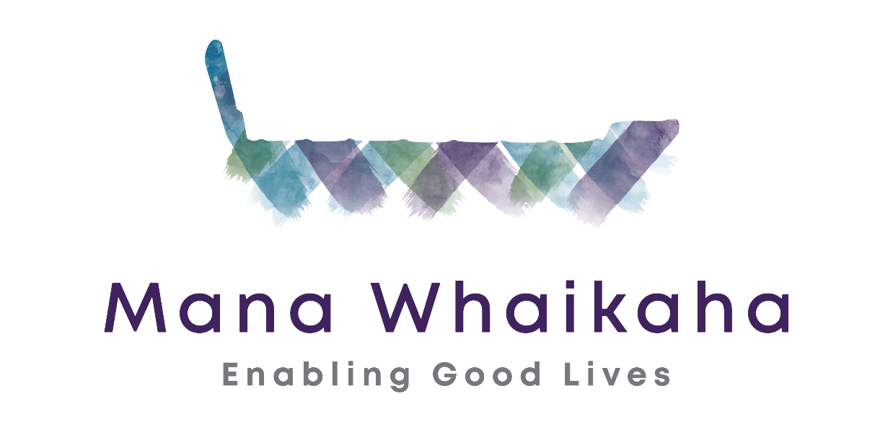
Understanding
Personal Budgets

0800 626 255 | 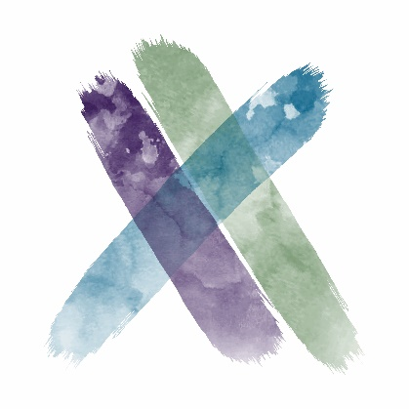 | PO Box 4547
Manawhaikaha.co.nz |  | Palmerston North 4442

Contents
Enabling Good Lives principles 5
Understanding personal budgets 6
What is a personal budget? 6
Who is eligible for a personal budget? 6
What can a personal budget be used for? 7
Is there anything that a personal budget cannot be used for? 7
How does a personal budget work? 7
What is the difference between an individually arranged personal budget and a centrally arranged personal budget? 8
Where does the money for personal budgets come from? 8
I want my current allocation in a personal budget – can I do that? 8
Are personal budget funds taxed? 8
Does personal budget funding affect my benefit? 9
Accessing personal budget funds 10
How do I access personal budget funds? 10
How does the Connector process work? 10
What is a funding proposal? 11
What information do I need to fill out a funding proposal? 11
What do I need to look for when signing a Funding Agreement? 11
What is a payment schedule? 11
Can I change my payment schedule? 11
Do I have to have my disability support money in a bank account? 11
What will be required of me if I want to have my disability support money in a bank account? 12
Banks won’t set up a bank account for my adult child, because they lack legal capacity. Does this mean I can’t get a personal budget? 12
I’ve previously had a stop payment with the Ministry of Health – will this affect my funding or funding arrangements? 12
For those that have a welfare guardian, how does that affect access to funding? 13
Managing a personal budget 14
How are personal budgets managed? 14
What if I want to keep some of my current supports? 14
If I manage my own personal budget, what are my responsibilities? 14
What monitoring/accountability is required from those with personal budgets? 15
If a disabled person manages their own personal budget, will it be counted as income or assets? 15
How will direct payments of disability support impact on GST (Goods and Services Tax) treatment? 15
What happens if a disabled person or their whānau spends their personal budget incorrectly? 16
Can I choose a Connector? 16
Do I have to work with a Connector? 16
Enabling Good Lives approach 17
The future disability support system 17

Enabling Good Lives principles
Self-determination
Disabled people are in control of their lives.
Beginning early
Invest early in families and whānau to support them; to be aspirational for their disabled child; to build community and natural supports; and to support disabled children to become independent, rather than waiting for a crisis before support is available.
Person-centred
Disabled people have supports that are tailored to their individual needs and goals, and that take a whole life approach rather than being split across programmes.
Ordinary life outcomes
Disabled people are supported to live an everyday life in everyday places; and are regarded as citizens with opportunities for learning, employment, having a home and family, and social participation - like others at similar stages of life.
Mainstream first
Disabled people are supported to access mainstream services before specialist disability services.
Mana enhancing
The abilities and contributions of disabled people and their families are recognised and respected.
Easy to use
Disabled people have supports that are simple to use and flexible.
Relationship building
Supports build and strengthen relationships between disabled people, their whānau and community.

Understanding personal budgets

What is a personal budget?
A personal budget is the amount of government funding a disabled person gets to pay for their disability related support.

Who is eligible for a personal budget?
To be able to access a personal budget through Mana Whaikaha, you will:
- Live in the MidCentral DHB region, which includes:
  - Palmerston North
  - Horowhenua
  - Manawatu
  - Ōtaki
  - Tararua districts.
- Have a disability
    - which is physical, intellectual, sensory or ASD, or a combination of these
    - that is likely to continue for at least 6 months
    - that limits your ability to function independently, to the extent ongoing support is required.
- Be under 65 years old (in most cases).
- Be a New Zealand citizen or permanent resident.

More detailed information on Disability Support Services criteria can be found on the eligibility page of the Ministry of Health website.

In addition, all children and young people under the age of 8 years who live in the MidCentral region, who are experiencing delayed development are eligible for intensive early intervention support. This means that a diagnosis is not required for children with developmental delay to be eligible to receive support. It is recognised that early access to support can have a significant positive impact on future outcomes for disabled children.

If you have psychiatric, health or age-related disability and require support, your local DHB can help.

What can a personal budget be used for?
Rather than being a one-size-fits-all approach, the personal budget provides disabled people and whānau with greater decision making over their support and more flexible support options. To use your personal budget for something, you need to be able to show how it helps you overcome a barrier as a result of disability. More guidance is available on Mana Whaikaha’s website.

Is there anything that a personal budget cannot be used for?
There are some things you can’t use your personal budget for, including:
- Illegal activities
- Gambling
- Alcohol
- Tobacco
- A personal injury that is covered by ACC
- Supplementing your general household income
- Paying for things another government agency funds*
Although there may not be a rule against using your personal budget for something, you may have to prioritise what you choose to spend your budget on depending on the amount of money you have in your budget.

*You may sometimes be able to use your funding for things another government agency funds (i.e. Ministry of Education or Work and Income). You can do this if the support from the other agency is not suitable for your needs or involves a long wait that would mean you could not achieve the life outcomes you are wanting. In this situation, you will need to give permission for Mana Whaikaha to talk about this with the other agency.

How does a personal budget work?
Your personal budget will be developed with you by deciding what is most important to you, exploring the options available to you in the community (including options funded by other agencies, or that don’t require funding), and developing a set of purposes that you might seek funding for through Mana Whaikaha.

The process involves providing some information about yourself, so that we can be confident we are treating all people fairly. For more information on how personal budgets are managed, see the section on managing a personal budget. Personal budgets can be individually arranged, centrally arranged, hosted by agencies or a combination of these.

What is the difference between an individually arranged personal budget and a centrally arranged personal budget?
There are different arrangement types you can choose for your personal Budget:
- Individualised Funding – centrally arranged personal budget that is managed by a provider or agency
- Hosted Personal Budgets – going to a providers account where they help the person manage their funding
- Individually Arranged Personal Budgets – funding goes directly to the person’s nominated bank account (keep in mind that it needs to be a separate account for disability funds not their ‘every day’ account).

Where does the money for personal budgets come from?
Personal budgets are primarily funded through Ministry of Health disability support. Some areas of Ministry of Health disability support funding are not included in personal budgets, but you can still access these supports through Mana Whaikaha. These include:
- Specialist services like Child Development Services and some Behaviour Support Services
- Equipment and Modifications funding
- Residential Care funding (but if you want a personal budget whilst living in residential care we can discuss this)
Education (ORRS) money does not go into personal budgets, it is separate.

Some Ministry of Social Development money can be included in personal budgets, including:
- Community Participation funding (Day programmes funded by MSD)
- Employment support
- Transitions funding

I want my current allocation in a personal budget – can I do that?
Personal budgets in Mana Whaikaha are not based on current allocations - you will need to go through the funding allocation process. For more information about the funding allocation process, see the section on accessing personal budget funds.

Are personal budget funds taxed?
No, your disability support funding won’t be taxed.

Does personal budget funding affect my benefit?
No, your disability support funding won’t be counted in any means testing by government.

Accessing personal budget funds

How do I access personal budget funds?
All funding requests, apart from requests for immediate assistance, need to go through the funding allocation process. To begin this process, you can contract Mana Whaikaha and ask to meet with a Connector. The Connector can then work with you to look at what you are wanting to achieve in your life and where the supports for this would best come from. Once you are your Connector agree to seek funding from Mana Whaikaha, you can then receive this funding as a personal budget. There are some rules about how you can use your personal budget as mentioned about. You can also get more information for the purchase guidelines section on the Mana Whaikaha website.

How does the Connector process work?
Connectors/Kaitūhonos and Mana Whaikaha contacts will work with disabled people and their whānau to:
- make it clear what they can expect from the system
- understand what’s important to the disabled person and their whānau
- explore and prioritise a range of support options with the disabled person and their whānau
- work with the person and their whānau to put a proposal together to seek funding
This proposal will then be reviewed by the funding team who review all funding requests so that the system makes fair decisions They will make funding decisions based on:
- the disabled person and their whānau having considered a range of options and what will be most cost-effective for them;
- the fairness of the funding sought relative to that sought by other people in similar circumstances;
- whether the overall package is too high or low compared with other people in similar circumstances;
- whether there is a strong argument for early investment;
- affordability within the overall budget for the MidCentral prototype.
Disabled people and whānau will get to make decisions on how to spend their government funding based on what is most important to them.

What is a funding proposal?
A funding proposal is a written request for funded services following a conversation between the disabled person, whānau and the Connector.

What information do I need to fill out a funding proposal?
- Information about who you are, what your life circumstances have been and what you are hoping to achieve in your life.
- Your purpose: what do you require the funding for? What do you want to achieve with this funding? You can have more than one purpose that you want funding for.
- Support: your choice of who, where and how you get your support. Options can be explored in discussion between the Connector and disabled person.
- Volume: how often do you require the support (daily, weekly, monthly, etc.)? How much support do you require.
- Verified bank account details (if required). You will need this if you are going to have a personal budget that you want to manage yourself.
- Duration of the funding proposal. Could be for 3, 6 or 12 months.
- Your choice of provider.
- Correct address and contact details.

What do I need to look for when signing a Funding Agreement?
- Your name and contact details are correct.
- Bank accound details are correct.
- Funding amount agreed to is correct.

What is a payment schedule?
Once the funding request has been approved, a payment schedule is created. This is a breakdown of when the funding will be paid to your bank account or to your provider. This could be fortnightly or monthly.

Can I change my payment schedule?
Yes, you can. You will need to give notice of change. Discuss this with your Connector who will follow the process.

Do I have to have my disability support money in a bank account?
No. There are a number of ways that you can receive your personal budget.
- You can ask that your personal budget be paid directly to your chosen provider – this is called “centrally managed.”
- You can have someone else manage your funding for you. This is call hosted funding. There are organisations that will host your funding for you. You can discuss this with your Connector.
- You can choose to have funding go into a bank account that you manage. However, this bank account needs to be a separate account and only your personal budget money can go into this account.

What will be required of me if I want to have my disability support money in a bank account?
You will need to go through the funding allocation process to have a personal budget allocated. If you want to manage your personal budget yourself, you will need to:
- Set up a separate bank account just for your disability support money;
- Comply with the funding agreement we make with you; and
- Provide us with a monthly bank statement for us to review, to make sure that everything is going as planned.
- You will also be responsible for employing your own staff and will need to understand the legal requirements around being an employer
We encourage you to work with a Connector if you want to manage your personal budget yourself.

Banks won’t set up a bank account for my adult child, because they lack legal capacity. Does this mean I can’t get a personal budget?
Your adult child can still get a personal budget. There are several options for how the money is managed in this situation:
- Having a third party manage the money in their account, and having a three-way contract between the fund manager, the disabled person, and Mana Whaikaha. The fund manager may be a parent, family member or trusted friend.
- In some instances, a joint account between yourself and your adult disabled child may be suitable.
It would be worth discussing these options with a Connector.

I’ve previously had a stop payment with the Ministry of Health – will this affect my funding or funding arrangements?
Not necessarily, but we would want to discuss the issue with you and ensure that you have appropriate support to manage your funding within Mana Whaikaha’s rules.

For those that have a welfare guardian, how does that affect access to funding?
We will need to include the welfare guardian in the process of thinking through any changes and in making funding decisions.

Managing a personal budget

How are personal budgets managed?
Disabled people and their whānau have a range of options to manage their support and funding. They can choose one or a combination of options:
- manage their support and funding themselves
- manage their support and funding with support from a host provider (disability or mainstream)
- contract a provider directly to deliver support
- have support and funding managed by a provider through a flexible disability support contract, where the provider delivers some support and arranges other support on their behalf.
- have support delivered by providers with the Ministry of Health managing the contract.
Disabled people and whānau can talk to the Kaitūhono/Connector or their Mana Whaikaha contact about what option would work best for them.

What if I want to keep some of my current supports?
You will have choice about what supports you use, and how the money is managed for them. For example, you may choose to access supports that are much the same as you receive now, and you may choose to access them from a Ministry funded provider. Or, you could choose to do something very different and manage the supports yourself. These are options worth discussing with a Connector. You may need to prioritise your supports to fit within the funding we can make available to you.

If I manage my own personal budget, what are my responsibilities?
Where all or part of a personal budget is being paid, responsibilities are:
- Recruiting, employing, managing and paying your own assistance/support staff
- Keeping records to verify the uses of the total amount of funding provided (i.e. employment records, invoices, receipts and/or transactions)
- Matching your expenditure to your agreed plan
- Meeting all obligations under all the relevant legislation (including, but not limited to, Employment Taxation and Health and Safety legislation)
- Giving Mana Whaikaha 14 working days; notice if you wish to change the type, amount or providers of your support.
- Telling Mana Whaikaha that you want to make immediate changes to the type, amount or provider of any of your support when personal safety is at risk.
- Meeting with Mana Whaikaha when they ask you to. Mana Whaikaha will agree a time with you that works best for both of us.

What monitoring/accountability is required from those with personal budgets?
If you want to access supports from providers, you will not need to provide us with any monitoring information. If you want to individually contract your supports, you will need to:
- Set up a separate bank account just for your disability support money;
- Comply with the funding agreement we make with you; and
- Provide us with a monthly bank statement for us to review, to make sure that everything is going as planned.
We encourage you to work with a Connector if you want to manage your personal budget through a bank account.

If a disabled person manages their own personal budget, will it be counted as income or assets?
No, disability support funding will not be considered as income or assets. Direct funding will not be taxed. It will not impact on access to other government assistance including:
- Working for Families tax credit entitlements
- Student loans or allowances
- Benefits, for example Jobseeker Support and Supported Living Payment
- Hardship assistance and Temporary Additional Support
- Supplementary assistance, for example the Accommodation Supplement, the Disability Allowance or through Ministerial welfare programmes
- Public housing and the level of Income Related Rent
- Residential Care Subsidy.

How will direct payments of disability support impact on GST (Goods and Services Tax) treatment?
If your disability support funding goes direct to providers, they are GST registered. This means they can claim it back. However, disabled people managing their own support and funding will not do this as they are not GST registered. Instead an additional 4.5% (approximately) will be added to your budget so that you are not disadvantaged by not being able to claim GST.

What happens if a disabled person or their whānau spends their personal budget incorrectly?
Mana Whaikaha will make sure that disabled people and whānau have clear information about their responsibilities. They will also assist you by putting supported decision-making in place for people who may need this guidance.

If you find that you are wanting to spend your personal budgets in a way that is different from what you agreed to at the beginning, you will need to contact your Kaitūhono/Connector or Mana Whaikaha contact to get agreement to the change.

Disabled people and whānau will need to provide a copy of their bank statements if they manage their funding themselves.

If disabled people and whānau cannot meet their obligations around managing funding, there will be options to provide coaching support to help them. If they still struggle to manage, or continue to use their funding inappropriately, then a decision will be made that their personal budget will have to be managed by a provider.

Can I choose a Connector?
You can choose your own Connector. However there can be quite a long wait list for your chosen Connector, and you might need to think about how long you can wait in order to get the person you want.

Do I have to work with a Connector?
You don’t have to work with a Connector. If you wish to seek funding from Mana Whaikaha without working with a Connector, you can self-connect. If you choose to self-connect, Mana Whaikaha will provide a contact person to support you along the way.

Enabling Good Lives approach
Through Enabling Good Lives, disabled people and their whānau can choose to increase the choice and control they have in their lives and supports.

The future disability support system

Vision
In the future, disabled people and their families, disabled children and adults will have greater choice and control over their lives and supports and make more use of natural and universally available supports.

Disabled people and their families, as appropriate, will be able to say:
  - I have access to a range of support that helps me live the life I want and to be a contributing member of my community.
  - I have real choices about the kind of support I receive, and where and how I receive it.
  - I can make a plan based on my strengths and interests.
  - I am in control of planning my support, and I have help to make informed choices if I need and want it.
  - I know the amount of money available to me for my support needs, and I can decide how it is used – whether I manage it, or an agency manages it under my instructions, or a provider is paid to deliver a service to me.
  - The level of support available to me is portable, following me wherever I move in the country.
  - My support is co-ordinated and works well together. I do not have to undergo multiple assessments and funding applications to patch support together.
  - My family, whānau, and friends are recognised and valued for their support.
  - I have a network of people who support me – family, whānau, friends, community and, if needed, paid support staff.
  - I feel welcomed and included in my local community most of the time, and I can get help to develop good relationships in the community if needed.
  - I feel welcomed and included in my local community most of the time, and I can get help to develop good relationships in the community if needed.

The Government will get better value for the funding it provides because:
  - the new approach will generally provide better quality of life outcomes for disabled people and their families (based on international evidence)
  - less money will be spent on providers premises and more on support
  - government agencies will work more closely together, for example using shared way to determine support needs, integrated funding and contracts.

Principles
Achieving our future vision for disability supports is complex and will take time. There will be many details to work through. A principles-based approach will ensure we stay on track to progress the vision. We will use the principles in the Enabling Good Lives report to help guide decisions on the changes.

Long Term Change Direction
Significant redesign and change will be needed on multiple fronts:
- Building knowledge and skills of disabled people: to ensure disabled people understand the direction for change and can exercise more choice and control over their supports.
- Investment in families/whānau: to assist them to support their disabled family member to have a good life and help them develop aspirations about what can be achieved.
- Investment to build inclusive communities: to ensure communities, including businesses, workplaces, schools, and cultural, sport and recreational activities, are accessible, welcoming and recognise the contribution of disabled people.
- Changing government systems and processes: to support the system redesign e.g. integrated, outcomes-focussed contracting, individualised funding, funding pooled from across Votes and involving disabled people and families in governance, system and service design and monitoring.
- Changes to service provision: to align service governance, delivery models, workforce capability, accountability measures, monitoring and evaluation with the vision and principles of the transformed system.

