

**Managing your Short Term Loan equipment service**

**Achieve efficient operation and management of DHB Short Term Loan equipment by implementing the STL system to request, dispatch, move, recall and return equipment.**

**Christine West, Business Services Manager**

**Short Term Loan implementation considerations**

The Short Term Loan system (STL) developed by Enable New Zealand provides functionality so a DHB can manage their short term loan inventory. This includes adding equipment, requesting equipment, dispatching equipment, moving equipment within your warehouse and to other DHB locations, returning equipment, recall of equipment and transferring equipment to Ministry of Health Long Term Loan. After implementation, it is expected the DHB will be able to manage their use of the system with minimal assistance from Enable New Zealand. Support is available as required.

**Warehouse security**

For any system to have data integrity, it is critical the equipment is where the system states it is. No equipment should be taken unless it has been requested and dispatched. If this does occur, it triples staff time taken to complete a request and dispatch:

* Stores staff spend time looking for equipment they believe to be available and then must find an alternative item
* Another Therapist’s time must be spent canceling a request for an item they believed to be available and requesting an alternative item

This practice will require frequent stock-takes to ensure inventory numbers are correct.

Similarly, if a Therapist receives an item from a patient, they need to ensure it is returned, so any recall tasks are cancelled. Returned items are automatically placed in a quarantine location to match cleaning protocols.

**Staff engagement**

A commitment from all staff to follow DHB processes will be critical to the success of implementing any inventory management system, including the Short Term Loan system.

**Warehouse locations**

DHBs need to identify what warehouses and locations they have in their region. How these are set up will define the available item quantities staff will be able to see. Some have one warehouse, e.g. Mid Central for Palmerston North and Levin hospitals. Some have two, e.g. Nelson/Marlborough for Nelson and Wairau hospitals*.*

Locations where equipment is stored need to be identified e.g. Main Store, Hospital – Level 7. This allows staff to view what equipment is at different locations.

**Identifying and labelling equipment items**

DHBs need to identify what equipment items they need to have in their catalogue. Enable New Zealand will supply a spreadsheet for recording catalogue items to ensure the required information is provided.

Some DHBs don’t track or asset label low cost items such as walking sticks, crutches and walking frame baskets. If a DHB has multiple variations of items, it is recommended they consider whether keeping all options is necessary, as having multiple variations increases the complexity of finding available assets.

DHBs need to order barcoded asset labels and it is recommended a barcode scanner and computer are located in the warehouse. Assessors/On Behalf Users also need access to a computer with internet access to view the inventory system and request items for patients.

Where the DHB has MOH Band 1 list items in their inventory, these are currently eligible for transfer to Long Term Loan where the client need changes from short to long term. The transfer can be transacted within the STL system.

|  |  |
| --- | --- |
| Examples of existing asset labelling: | |
| MOH Asset Label | MDHB Asset Label |
| cid:image006.jpg@01D4D2AE.5B39BCC0 | cid:image010.jpg@01D4D2AE.5B39BCC0 |
| SDHB Asset Label | NMHealth |
| cid:image001.jpg@01CC0B25.2440BE20 |  |

**System setup**

Enable New Zealand will load the catalogue of items. DHBs need to complete a stock take identifying all inventory items in the store and at off-site locations. Enable New Zealand will supply a stock take spreadsheet to ensure all required information is recorded. Enable New Zealand will then import the inventory items spreadsheet provided by the DHB.

Enable New Zealand may be able to import some client data subject to review of the quality of the data. The STL system works best with Google Chrome, so this browser should be installed on PCs.

**Identify users**

DHBs will identify who needs login access to the system and provide name, address, email, phone and EMS Assessor code (if an EMS Assessor) to Enable New Zealand. Enable New Zealand will supply a spreadsheet to capture the required data. Enable New Zealand will also need to be informed about the following roles: Store Person, Assessor, On Behalf User (Allied Health Assistant). If a DHB does not have dedicated stores staff but assessors need to request and dispatch equipment, a dual role may be necessary. Enable New Zealand will send login details to new users.

**Training**

Enable New Zealand has recorded training videos so staff can complete self-paced learning. If a DHB requires on-site training, this can be discussed with Enable New Zealand.

**Implementation support**

Enable New Zealand will provide implementation support on-site for 2-3 days. It would be preferable for the DHB to identify a couple of key ‘super-users’ and for the super users to be available for a session with Enable New Zealand during implementation on-site support. Further support is available via email or zoom teleconference.

Enable New Zealand will provide a contract for an appropriate DHB manager to sign agreeing term of use, contract price, roles and responsibilities.

**Preparation checklist**

* DHB advises Enable New Zealand they are interested in Short Term Loan system
* Enable New Zealand and DHB agree on an implementation timeframe
* Enable New Zealand sends a contract to DHB
* DHB confirms inventory is securely managed
* DHB ensures technology requirements are met (PCs, Internet Browser, scanner)
* DHB identifies the number of warehouses and locations required
* Enable New Zealand supplies a spreadsheet for identification of DHB staff who need access to the system
* DHB sends the list of staff requiring access (including roles) to Enable New Zealand
* Enable New Zealand supplies a spreadsheet for required catalogue items
* DHB identifies what items they need in Short Term Loan catalogue
* Enable New Zealand match DHB catalogue items to MOH Band 1 list so Short Term to Long Term Loan is possible (where appropriate)
* DHB organises asset labels (in discussion with Enable New Zealand re format)
* Enable New Zealand supplies a spreadsheet for DHB to stock-take locations and record assets
* DHB organises staff to complete video training session
* Enable New Zealand books travel/accommodation for on-site implementation support

**System screenshots**

Request screen:

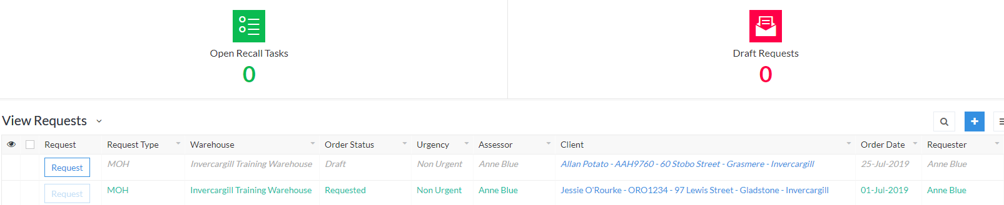

Viewing items requested for dispatch:

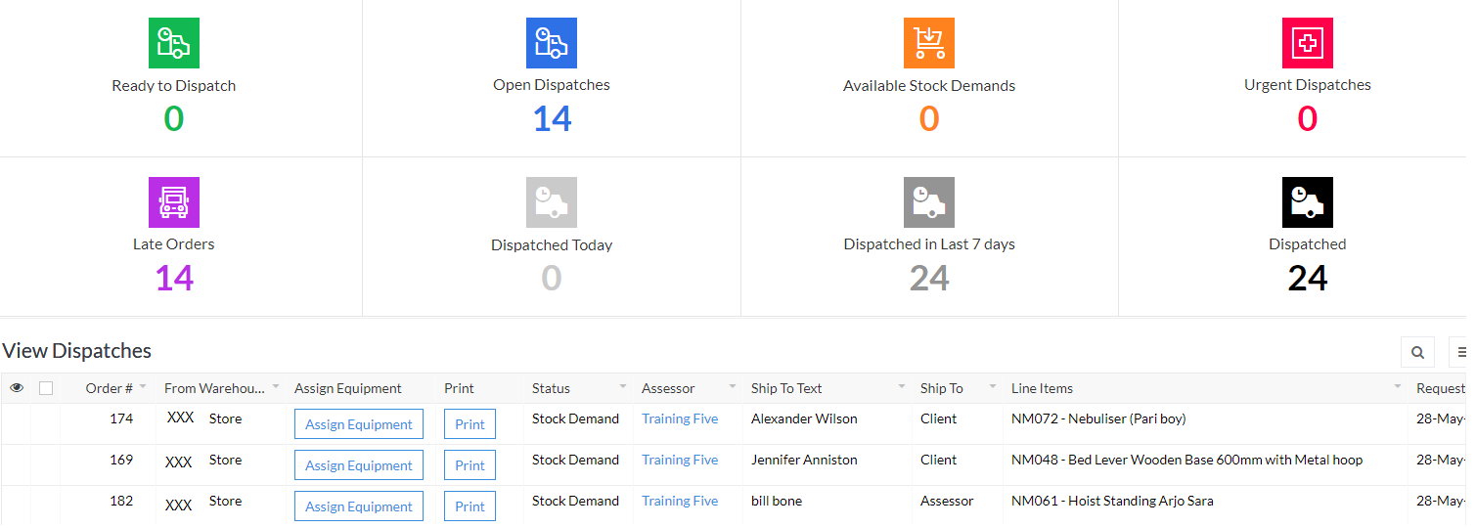

Viewing inventory:

