Registration of Interest as a Contractor for Whaikaha Housing Modifications
To be completed by the Contractor (please note incomplete forms may not be considered or may be returned for completion).

Contractor Company Details
Legal Entity Name
Company/Trade Name
Street Address
PO Box Number
Town/City
Post Code (Physical) Post Code (Mail)
Telephone ( ) Mobile ( )

Key Contact Details
Name Email
Phone ( ) Preferred Method

Territorial Areas as defined by Enable New Zealand
Please tick below the Territorial Areas you would like to be considered for. To do so, double click on a box and select “checked.” See Appendix 1 on page 7 for a map of these areas.
Waikato
Hamilton City | Hauraki District | Matamata-Piako District
Otorohanga District | Waitomo District | Ruapehu District
South Waikato District | Waikato District | Waipa District
Thames-Coromandel District
Bay of Plenty
Western Bay of Plenty District | Tauranga City | Whakatane District
Kawerau District | Opotiki District
Taranaki
South Taranaki District  (Whenuakura North) | Stratford District | New Plymouth District
Hawkes Bay
Central Hawk’s Bay District | Hastings District | Wairoa District
Napier City
Lakes
Rotorua District | Taupo District
Tairawhiti
Gisborne District
Whanganui
Ruapehu District (South of the  Maktote Viaduct) | Whanganui District  (Whenuakura South) | Rangitikei District
MidCentral
Horowhenua District | Manawatu District | Palmerston North City
Kapiti Coast District (Peka  Peka North) | Tararua District
Wairarapa
Carterton District | South Wairarapa District | Masterton District
Capital & Coast
Kapiti Coast District  (Peka Peka South) | Porirua City | Wellington City
Hutt
Lower Hutt City | Upper Hutt City
Canterbury
Ashburton District | Hurunui District | Kaikoura District
Chatham Islands Council | Selwyn District | Waimakariri District
Christchurch City (including
Banks Peninsula)
Nelson Marlborough
Marlborough District | Tasman District | Nelson City
West Coast
Westland District | Buller District | Grey District
Southland
Invercargill City | Southland District | Gore District
South Canterbury
MacKenzie District | Timaru District | Waimate District
Otago
Central Otago District | Clutha District | Dunedin City
Queenstown-Lakes District | Waitaki District

Type of Business
(Please provide copies of trade qualifications)
Building Contractor
Engineer
Licensed Building Practitioner (License Number)
Other (please state)

Type of Work
Please tick below the Housing Modifications work you are qualified for or capable of completing. Find definitions for Basic and Complex Modifications in Appendix 2, Page 8 or in the Housing Modifications Manual.
Handrails
Basic
Complex

Insurance Information
Do you have Public Liability Insurance? Yes No $
Do you have Contractors All Risk Insurance? Yes No $
Please provide written evidence from your Broker of the insurance cover clearly showing the expiry date. Details attached Yes No Expiry Date / /

Professional Membership
Certified Builders Association
Master Builders Association
Other (please state)
Please provide details of Professional Membership
Details:

Length of membership Expiry Date / /

Experience
Are you a current Building Contractor with Enable New Zealand?
Yes (if yes, go to the Conflict of Interest Declaration section)
No
Please provide summarised details of your relevant experience below:
Also attach CV or Portfolio

Form continues on next page

Verbal Referees
Please list the names and contact details of at least three verbal referees to support your application:
- Phone ( )
- Phone ( )
- Phone ( )
- Phone ( )

Conflict of Interest Declaration
The Respondent warrants that it has no actual, potential or perceived Conflict of Interest in submitting this Registration, or entering into a Contract to deliver the Requirements. Where a Conflict of Interest arises during the procurement process the Respondent will report it immediately to the Buyer’s Point of Contact.
Agree
Disagree

Details of Conflict of Interest:

Declaration
I/we declare that in submitting the Registration and this declaration:
- the information provided is true, accurate and complete and not misleading in any material respect
- the Registration does not contain Intellectual Property that will breach a third party’s rights
- I/we have secured all appropriate authorisations to submit this Registration, to make the statements and to provide the information in the Registration and I/we am/are not aware of any impediments to enter into a Contract to deliver the Requirements.
I/we understand that the falsification of information, supplying misleading information or the suppression of material information in this declaration and the Registration may result in the Registration being eliminated from further participation in the ROI process and may be grounds for termination of any Contract awarded as a result of the ROI.

By signing this declaration the signatory below represents, warrants and agrees that he/she has been authorised by the Respondent/s to make this declaration on its/their behalf.

Signature Date / /

Full Name

Title / Position
Name of Organisation

Checklist for Contractor
All sections of Registration of Interest Form are completed (including the Supplier Form)
Evidence of insurance attached that shows amount of cover and expiry date
List of at least three referees
Bank account details provided (with supporting documentation)
CV or portfolio attached
Conflict of Interest Declaration
Declaration understood and signed

To allow consideration of your organisation for Contractor Services relating to Housing Modifications funded through the Ministry of Health, this form must be completed in full.

Appendix 1 – Map of Territorial Areas
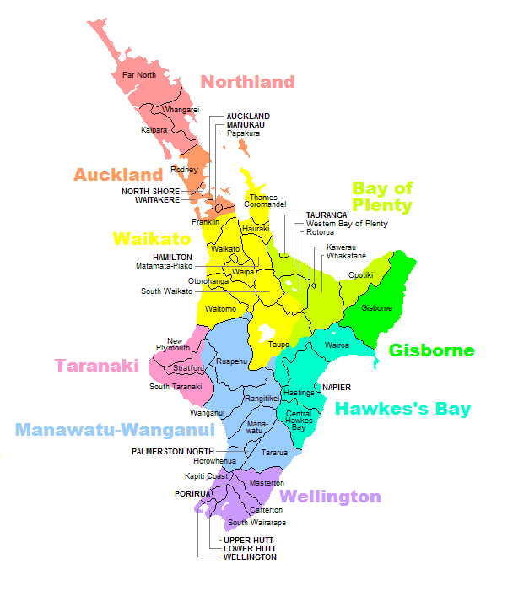

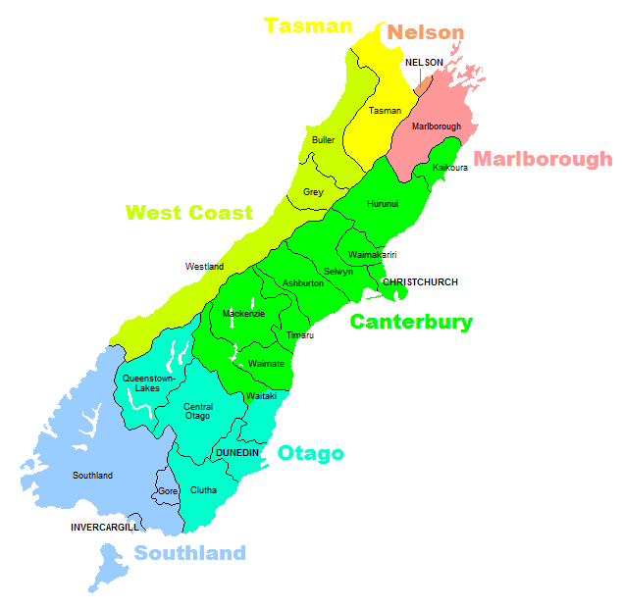
South Canterbury

Appendix 2 – Definition: Basic and Complex

Housing Modifications
Ctrl+Click here for Housing Modifications Manual

Basic
- Basic housing modifications are low cost, generally under $2,000 (GST excl.) and do not require significant structural work or building consent. Basic housing modifications include, but are not limited to, external and internal handrails, internal door widening, lever taps and threshold ramps
- Examples
- External Handrails
- Internal Handrails
- Internal Door Widening
- Lever Taps
- Threshold Ramps

Complex
- Complex modifications generally cost more than $2,000 (GST excl.) and involve more significant structural work. They may require building consent. In order to recommend complex housing modifications an EMS Assessor needs to be an occupational therapist who is a Credentialed Assessor for Housing Modifications (Complex) under the EMS Assessor Accreditation Framework.
- Examples:
- Access Modifications
- Easy-steps
- Ramps
- Low rise platform lifts
- Stair lifts
- Multi-floor platform lifts
- Replacement of Access Equipment – Like for Like
- Other External Modifications
- Automatic door openers
- Covered transfer areas
- External door widening
- External linking rails and modifications to existing paths
- Internal Modifications
- Internal door widening
- Wall removal or minor internal redesign
- Ceiling mounted overhead hoists
- Heating, air conditioning and lighting
- Level access showers
- Vanity units and hand basins
- Toilets
- Bidets
- Kitchen modifications
- Room extensions
- Modifications to support people who have challenging behaviour
- external fencing
- safety glass
- security or stable doors
- reinforcement of walls
- window restrainers

