Guide for EMS assessors
Modular Ramps

When considering access with a total rise of over 1 meter, EMS assessors are required to consult with a Clinical Services Advisor. A Clinical Services Advisor can be consulted on Whaikaha – Ministry of Disabled People’s eligibility, access criteria and ramp solutions.
Modular ramps are generally aluminium and made up of interlocking parts that are assembled on site. If Whaikaha – Ministry of Disabled People (Whaikaha) funding is going to be considered, note that the ramp is owned by Whaikaha and on long-term loan to the person for as long as needed. When the ramp is no longer needed the ramp will be removed by Whaikaha and refurbished for another person to use.

Considerations for Modular Ramping
Consider which entrance is the most practical and cost-effective to modify, such as the:
- Closest access to where a vehicle can reasonably be parked.
- Total rise and the space available / environment to achieve the required gradient.

Please note: Whaikaha funding can only be used for one entrance to the home (Section 6.1. of the EMS Housing Modification manual)

Gradient
- Length of ramp = height of step or rise multiplied by desired gradient.
- Consider how the client mobilises. Are they ambulant and/or do they currently use mobility equipment, or likely to use it in future? If a wheelchair is likely to be used in future, is this likely to be a manual or powered wheelchair?
- The slope or rise is the difference in height between the start to finish point of the ramp.
- A gradient of 1:12 is generally appropriate.

Environment
- Consider the slope of land. This may require the ramp to be longer to achieve the desired gradient, i.e., if the land slopes away from the house.
- The position of the ramp must be clear of any areas that may create a risk. For example, open windows (window stays can be used to restrict the opening), low covered porch, outward opening doors, water tap, aircon unit, gully trap, drains, pipes etc
- Ramps must end on the client’s property, not on shared ownership, shared driveways or communal land.

Landing platform
- A level landing platform (generally at least 1200mm long) is required at the door entrance to enable safe operation of the door.
- Additional landing platforms are generally required when a ramp is longer than 4m.

General specifications
- Ramps are 1000mm wide with a 75mm up-stand on both edges. Wider, heavy-duty ramps (1200mm wide) are available if required.
- Handrails are generally required. Either on one or both sides depending on the environment.

Information for modular ramp applications

Photographs of the existing environment

Please supply at least three photos.
1) Towards access
2) Away from access
3) The wider environment
Include photos of vehicle access if relevant.

Example photos courtesy of Able Axcess
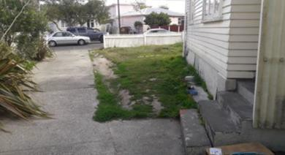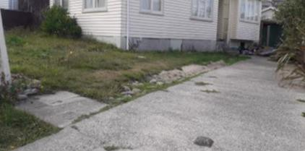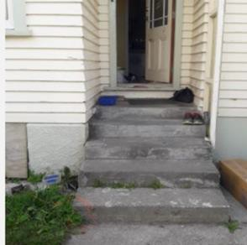

Sketches–existing and proposed.
Provide a signed sketch of the existing environment (bird’s-eye view) and a sketch of the proposed ramp solution.
Use consistent units of measurement e.g., mm (metric).

Bird’s-eye view example
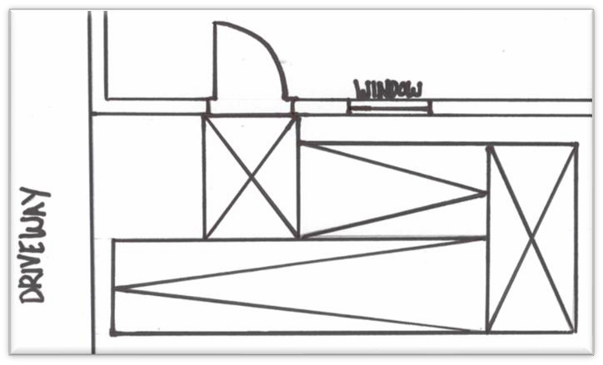

Image courtesy of Able Axcess

A rough sketch showing a bird’s eye view of the house, indicating all access points and/or a photo of any alternative access point is helpful to confirm the preferred place for the modification. As is normal practice please consider the most suitable value-for-money option, for long-term use.

Other Documents
- Completed scheduled summary
- Signed terms and conditions
- Property owner approval form
- Kianga Ora (Housing Modifications in Housing New Zealand Houses) form
- EMS (Whaikaha) portal document

Acknowledgement: Enable New Zealand Ltd would like to acknowledge Able Axcess, modular ramping specialists, for their help with this guide. Able Axcess can be contacted on 0800 436 773 www.ableaxcess.co.nz

